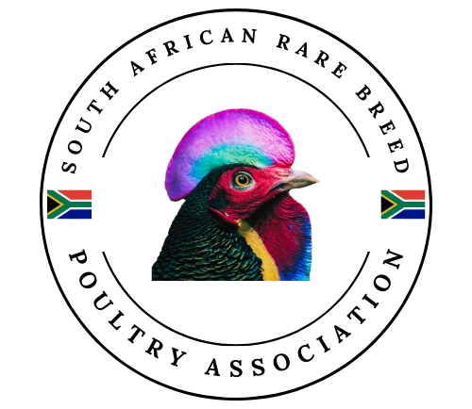
Application For Membership

Name: ___________________ Surname: ______________________
ID No: ___________________
Residential Address: ________________________________________________________________________
________________________________________________________________________
Cell No: (____) -_____- _____ Email: _________________________

Are you a SASPO Member? Yes No
If “yes”, please provide your SASPO No and your SASPO Affiliated Club.
SASPO No: ____________ SASPO Affiliated Club: _______________________
Do you wish to move your SASPO affiliation to this club going forward?
Yes No

What varieties of rare breeds do you own: __________________________________________________________________________________________________________________________________________________

Declaration of Applicant
By my signature hereto and/or by payment of the relevant fees, I signify my agreement to the following: That my application for membership is subject to the relevant requirements as contained in the Statutes being.
- the Club’s Constitution and
- any relevant SASPO Statutes (obtainable from the SASPO website www.saspo.org.za).
That I undertake to comply fully and punctually with and adhere to the Statutes of the South African Rare Breed Poultry Association (SARBA) as well as the SASPO rules and regulations.

General Information
- Fees are payable annually, and membership runs from July to June of the following year.
- If you are affiliated with SASPO through another club, only the Annual Membership Fee is payable.
- If you are affiliated with SASPO through this club, the Annual Membership Fee plus the Annual SASPO Affiliation Fee is payable.
Type of membership | Annual Membership Fee | Annual SASPO Affiliation Fee | TOTAL
Ordinary Membership | R100 | R220 | R320

BANKING DETAILS:
Account Name: Rare Breed Club
ABSA
Account no: 080155069
Branch Code: 334245
Please take note to: Add your name and/or surname followed by rare breed on the payment reference. i.e. “Chantal rare breed” as the reference.
Please send Application and Proof of Payment to rarebreedsouthafrica@gmail.com

- Poultry Shows are held throughout the year, but mainly between March and June, therefore membership extends from July of the current year to June of the following year.
- All poultry that are to be entered in a show (except Agricultural Shows) must be ringed with a SASPO approved ring.
- Poultry rings are ordered tri-annually, and the Ring Master will inform members when to order.
- Official SASPO rings may only be issued to SASPO members.
- SASPO and SARBA Honorary Members do not pay any fees, but SARBA Honorary Members must pay the SASPO Affiliation Fee

Date: Signature:
202_ / __ / __ ____________________

