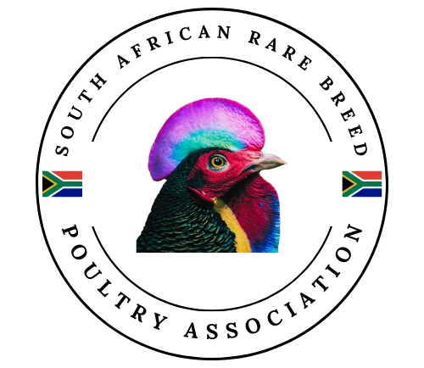
Application for Membership

Name: |  | Surname:

ID No:
   |  |  |  |  |  | - |  |  |  |  | -
Residential Address:

Cell No:
   |  |  | - |  |  |  | -
Email:

Are you an existing SASPO Member? | Yes |  | No

If “yes”, please provide your SASPO No and your SASPO Affiliated Club.
SASPO No: |  | SASPO Affiliated Club:

Do you wish to move your SASPO affiliation to this club going forward?
Yes |  | No
Which rare breeds do you own:

Membership Fees
Membership Fees from July to June:
Type of membership |  | Annual Membership Fee |  | Annual SASPO Affiliation Fee | TOTAL
Ordinary Membership |  | R 100 |  | R 240 | R 340
 | Banking Details:
 | Account Name: |  | Rare Breed Club
 | Bank: |  | ABSA
 | Account no: |  | 080155069
 | Branch Code: |  | 334245
Please take note: Add your name or surname followed by “rare breed” in the payment reference. i.e. “Chantal rare breed” as the reference.
Please send your completed Membership Application Form and Proof of Payment to rarebreedsouthafrica@gmail.com.

General Information
- Membership runs from July to June of the following year.
- Renewal fees are payable annually between July and January.
- Fees must be paid before the end of January; otherwise, membership lapses.
- Any new applications and fees received between July and January will apply to the current July to June period.
- Any new applications and fees received between February and June will apply to the current July to June period - rings may still be ordered until the renewal deadline in the next January.
- If you are affiliated with SASPO through another club, only the Annual Membership Fee is payable.
- If you are affiliated with SASPO through this club, the Annual Membership Fee and the Annual SASPO Affiliation Fee are payable.
- Poultry Shows are held throughout the year, but mainly between March and June.
- All poultry that are to be entered in a show (except Agricultural Shows) must be ringed with a SASPO poultry ring.
- Poultry rings are ordered tri-annually, and the Ring Master will inform members when to order.
- Official SASPO rings may only be issued to SASPO members and are for identification purposes and not an indication of quality.
- SASPO and SARBA Honorary Members do not pay any fees, but SARBA Honorary Members must pay the SASPO Affiliation Fee.

Declaration of Applicant
By signing this declaration and/or by paying the relevant fees, I confirm my agreement to the following.
My application for membership is subject to the applicable requirements contained in the following statutes:
- the Club’s Constitution and
- any relevant SASPO Statutes (obtainable from the SASPO website www.saspo.org.za).
I undertake to comply fully and promptly with the Statutes of the South African Rare Breed Poultry Association (SARBA) and the rules and regulations of SASPO.
I acknowledge and agree that the club and SASPO may store and use the personal information that I provided for internal official purposes only.
I also acknowledge and agree that my name, surname and SASPO number may be published publicly for official purposes, such as show result cards and show catalogues.

We value your privacy. On occasion, it may be necessary to share your phone number or email address for event coordination or official enquiries. Please indicate below which information you consent to us sharing for these purposes:
I consent to my phone number being shared for these specific purposes.
I consent to my email address being shared for these specific purposes.
Note: You may withdraw or change your consent to the sharing of your phone number or email address at any time by contacting rarebreedsouthafrica@gmail.com.

Date: |  | Signature:
2 | 0 | 2 |  | / |  |  | /

